UNIVERSITY OF DAR ES SALAAM

COLLEGE OF INFORMATION AND COMMUNICATION
TECHNOLOGIES
DEPARTMENT OF COMPUTER SCIENCE AND ENGINEERING

IS335 FYP MID SEMESTER 2 REPORT

PROJECT TITLE:DESIGN AND IMPLEMENTATION OF LEAVE AND TRAINING MANAGEMENT SYSTEM
NAME: NICHOLAUS, Salmon Emmanuel
REGISTRATION NUMBER: 2017-04-01596
COURSE: Bachelor of Science with Computer Science
Name of Supervisor: Engineer. Daudi Charles Supervisor’s signature: …………………...

DECLARATION

I NICHOLAUS, Salmon E of Registration number 2017-04-01596 hereby declare that this Project Report titled Design and Implementation of Leave and Training Management System was prepared by me. This report is prepared and written according to the rules and regulations of the College of Information and Communication Technologies (CoICT) of University of Dar es Salaam (UDSM) to fulfill the curricular requirement of Bachelor of Science with Computer Science.

NICHOLAUS, Salmon E 2017-04-01596

Signature: _________________

Date: _________________

Supervisor’s signature

…………………………..

Date

…………………….

ABSTRACT

The project in brief intends to solve lack of leave and training management system that happens to be one of the biggest challenges atMorogoro Urban Water Supply and Sewerage Authority. The system used to manage the leave management at MORUWASA is still a paper work which make difficult to manage the paper, since when an employee wants to request a leave he or she must fill a form and send to head of the section, then the head of the section send it to the HR manager then MD approval or reject leave according to the policies or rules concerned and hence cause the loss of time to the employee and also to the managers. So under this situation the project will help in time management on leave and training issues.
This report explains about using web application to deliver leave and training system that will help employees at MORUWASA to have the access of requesting leave and training through the system and get response of their application through a system, so this may lead to save time and manage data loss through a system.
The web application for leave and training management system is there to help user in eliminating paperwork, removes manual interventions, improves communication, offers real-time visibility of data ,ensures legal compliance and also will help employees to acquire and improve knowledge, skills and attitudes towards work related tasks. This report gives a detailed information on designing and implementation of Leave and training management system, this project will create a bridge between employees and access to a leave and training. The project takes advantage of fast growing Information Technology (IT), which comes with many advantages includes flexibility and accessibility, hence I recommend the government institutions to use the computerized systems like leave and training management system in their organization. The report describe the problem statement, significant of the solution, scope of the solution and also it shows the methodologies, literature review , system analysis used on solving the problem and implementation of the system.

ACKNOWLEDGEMENTS
I extend my gratitude to the almighty God for the grace he gave me throughout my life and specifically during the preparation of this report. I would also like to thank all members of the CoICT-CDE Projects which are; Mr Fredrick Ishengoma, Madam Eva Shayo, Madam Christine Mwase, Madam Rahabu Mwang’amba, Madam Merina Marcelino, Dr. Musa Kissaka, Dr. Khamis Ndyetabura, Dr. Baraka Maiseli, Mr Shamte Kawambwa and Eng. Daudi Charles without forgetting all other people who positively supported me throughout the practical training time.

My sincere gratitude goes to Eng. Daudi Charles for his close supervision, advice and commitment.

I also extend my gratitude to the entire Morogoro Urban Water Supply and Sewerage Authority team for cooperating with us and also or trusting the abilities we have in solving the challenges they presented to us. To mention a few, I would like to thank Mr. Alphonce Kilima, Madam Catherine Theodore, Mr. Malik Ali, Mr. Walioba Ismail, The HR and IT department for sacrificing their time to share knowledge with us.

TABLE OF CONTENTS
DECLARATION ii
ABSTRACT iii
ACKOWLEDGEMENTS iv
TABLE OF CONTENTS v
LIST OF ABBREVIATIONS ix
LIST OF FIGURES x
LIST OF TABLES xi
CHAPTER ONE 1
INTRODUCTION 1
1.1 Background 1
1.2 Problem statement 2
1.3 Objective 3
1.3.1 General Objective 3
1.3.2 Specific Objectives 3
1.4 Significant of the Solution 3
1.5 Scope of the Solution 4
1.5.1 Limitation of the Solution 4
1.6 Organization of the Report 4
CHAPTER TWO 5
LITERATURE REVIEW 5
2.1 Existing System at MORUWASA. 5
2.1.1 Status of Leave 5
2.1.2 Drawbacks of the Existing Solution 6
2.2 Related Works 6
2.3 Overview of the Proposed System 8
2.4 System Development Model 9
2.4.1 Comparative Study on Development Methodology 9
2.4.2 Agile Model 9
2.4.3 Pattern-Oriented Software Architecture 10
2.5 System Architecture 10
CHAPTER THREE 11
METHODOLOGY 11
3.1 Overview 11
3.2 Project Methods 11
3.2.1 Requirements Gathering Method 11
3.4 Software Development Method 12
3.3 Data Analysis and Results 13
3.3.1 Data Analysis 13
3.3.2 Data Results 14
CHAPTER FOUR 16
SYSTEM ANALYSIS AND DESIGN 16
4.1 Requirements Analysis 16
4.1.1 Functional Requirements 16
4.1.2 Non-functional Requirements 17
4.2 Use Case Analysis 17
Use Case Analysis for Leave 18
4.2.1 Employee and Managing Director 18
4.2.2 Admin and Head of Section 19
4.2.3 HR Manager 20
4.3 Use Case Description for Leave and Training Management System 20
4.4 SYSTEM DESIGN 28
4.4.1 Overview 28
4.4.2 Process Modeling 28
Leave and training system is a client-server, web-based system with three tier architecture. The system consists of three major components 31
4.3.3 Leave and Training system architecture 31
CHAPTER FIVE 33
SYSTEM IMPLEMENTATION 33
5.1 Overview 33
5.2 Implementation Strategy 33
5.3 Coding of the Component 33
5.4 Component Prototype 34
CHAPTER SIX 39
CONCLUSION AND RECOMMENDATION 39
6.1 Conclusion 39
6.2 Challenges 39
6.3 Recommendation 39
6.4 Work which have been Done 39
6.5 Work to be done 39
REFERENCES 40
APPENDECIES 41

LIST OF ABBREVIATIONS

DBMS | Database Management System
DFD | Data Flow Diagram
HR | Human Resource
MORUWASA | Morogoro Urban Water Supply and Sewerage Authority
MVC | Model View Controller
IT | Information Technology
RAD | Rapid Application Development
SDLC | Software Development Life Cycle

LIST OF FIGURES

Figure 1.1: Breakdown of inefficient human resource management system 2
Figure 2.2: Showing the status of leave at MORUWASA 5
Figure 2.3: Showing the work through of the proposed solution 9
Figure 2.4: Showing the system architecture 10
Figure 3.5: Showing some of the modules which are manual at MORUWASA 12
Figure 3.6: Showing the agile development processes 13
Figure 4.7: Showing the use case of employee and managing director 18
Figure 4.8: Showing the use case of admin and Head of section 19
Figure 4.9: Showing the use case of HR manager Use case analysis for training 20
Figure 4.10: Showing the use case of training system 20
Figure 4.11: Diagram for leave management system DFD for HR Manager 28
Figure 4.12: DFD for HR Manager 28
Figure 4.13: DFD for Employee 28
Figure 4.14: DFD for Managing director 29
Figure 4.15: Showing the DFD level one of Managing Director 29
Figure 4.16: Showing the architecture of the leave and training management system 30
Figure 4.17: ER Diagram 31
Figure 5.18: Login form 33
Figure 5.19: Requesting or application form 34
Figure 5.20: Leave history of employee before approved 34
Figure 5.21: Leave history of the employee after approved 35
Figure 5.22: Managing director leave requesting by employee 35
Figure 5.23: Register user 35
Figure 5.24: Change password 36
Figure 5.25: Login Interface 36
Figure 5.26: Employee interface of training system 36
Figure 5.27: Requesting schema 37
Figure 5.28: Managing director login Schema 37

LIST OF TABLES
Table3.1: Showing the interview questions and the response 14
Table4.2: Showing use case for login 20
Table 4.3: Showing the login 21
Table 4.4: Showing Employee Registration use case 21
Table 4.5: Showing apply leave use case 23
Table 4.6: Showing approve/reject leave use case 23
Table 4.7: Showing View notification use case 24
Table 8: Showing View leave history 25
Table 4.9: Showing upload report use case 26
Table 4.10: Apply training use case 26
Table4.11:showing add training in the system 27
Table 4.12: Showing training approve use case 27
Table 13: A1 Time scheduling 41

CHAPTER ONE

INTRODUCTION

1.1 Background
The project is part and parcel of Challenge Driven Education which is essentially an academic platform intending to use the skills and knowledge obtained from the school and colleges to solve different challenges drawing us back from archiving sustainable development goals. In our colleges in pursue of solving these challenges, we started with the water sector and specifically our college targeted Morogoro Urban Water Supply and Sewerage Authority. MORUWASA is an organization dealing with Urban Water Supply and Sewerage management at Morogoro specifically the urban area as the MORUWASAs long form suggests. MORUWASA submitted the general challenges facing their organization from sections which are production, Network and general operation and Human resource. Students from the CDE team selected the section on which they would deal with where the selected section for our team was human resource section.

Human resource management is all about increasing employee performance to their highest level corresponding to their role in the organization. It is concerned with management of employees from recruitment to retirement. Five major functions of Human resource management include Recruitment and selection, Performance Appraisal, managing employee relations as in equal opportunity monitoring and leave management, Training and development, Reporting and payroll functions. (Bhattacharyya, 2017).

Main challenge presented from MORUWASA on the Human resource section is lack of computerized human resource management system. Later on the main challenge presented was modified to inefficient computerized human resource management system because it is not like there is completely lack of computerized human resource management system but there are some components of human resource management system that are automated already like the payroll system and the fingerprint for attendance but most of components like training information, performance appraisal and leave information are still operated manually. Inefficient management of human resource is a wide field therefore the challenge was broken down into sub component as shown in Figure 1.1
MORUWASA has poor and inefficient means of managing human resources, this is because most of the activities of HRM are done manually due to lack of a proper computerized system that can integrate all the existing systems at MORUWASA to a single powerful system

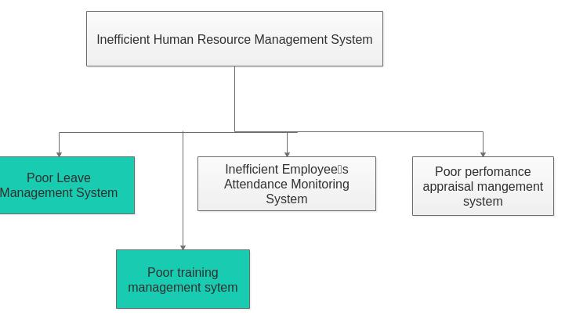

Figure 1.1: Breakdown of inefficient human resource management system

The present state of managing Human Resource at MORUWASA is that they still use the manual way of recording the data and actually most staff members don’t take it serious on matters concerning performance appraisal. Also, the issue about the current state of the performance appraisal system is that the files have to Rom to and from various people and the chance of the files getting lost is very high.

1.2 Problem statement
The inefficiency method of handling leave and training lead to time wastage this is due manual system of leave requesting and managing has no way of identifying if the leave request has reached the limit on a certain department, since it can happen that all the people on the certain department has a leave and hence lead to poor management of the organization due to lack of people to assign the activity. Also, an employee needs to submit their leave and training manually to their respective authorities or department, this increases paperwork and maintaining the paperwork becomes a tedious exercise.

1.3 Objective
The project objectives are mainly divided into two parts.

1.3.1 General Objective
The main objective of this project is to design and implement the leave and training management System where-by employee will be able to access different training, requesting leave or training and also will help in easy availability of data when needed.

1.3.2 Specific Objectives

- To gather and analyze requirements for the system.

- To design the leave and training management module

- To design the database of leave and training module

- To implement the leave and training management system

- To test the leave and training system

- To document the leave and training management system

1.4 Significant of the Solution
A leave management system is an all-in-one platform that handles all employee vacation requests while ensuring smooth functioning of their operations. Here’s what a robust leave management software does

- Eliminates paperwork

- Removes manual interventions Improves communication

- Offers real-time visibility of data Ensures legal compliance

- Reflects your organization’s values.

- The training system will help employees to acquire and improve knowledge, skills and attitudes towards work related tasks.

- The training system provides recognition, enhanced responsibility and the possibility of increased pay and promotion (Cole, 2001).

1.5 Scope of the Solution
The Leave and training management system handles all process for leave training applications or request and approval review process usable at MORUWASA. A dynamic database will be used to hold all applications details and keep data in a way that it can be viewed by management to make prompt informed decisions on approvals and staffing levels. A simple interface will be in place making it easy and simple to use for all employees and management. A comprehensive documentation to assist in the maintenance, customizing and adding more features to the system.

1.5.1 Limitation of the Solution
- The system will only be used with only the authorized user; thus, employee will have to login into system and access the service.
- The organization will also be hosted to a local server for security purpose

1.6 Organization of the Report
This report is divided into five chapters, Chapter One, this part consists of the background of the problem, statement of the problem, objectives (i.e. general objectives and specific objectives), significance of the project, scope and limitation. Chapter Two covers the Literature Review, which consists of a clear description of the problem together with research findings from the research and surveys conducted. Chapter Three explains about all the methods undertaken to obtain information about the problem (researches and surveys) are explained in detail. Chapter four explains about system analysis and designing of the proposed system. Chapter five explains about the implementation and chapter six explains about conclusion and recommendation on the project.

CHAPTER TWO

LITERATURE REVIEW

2.1 Existing System at MORUWASA.
The existing paperwork related to leave management. When employee need leave he or she is required to fill the form for requesting a leave and then the form is required to be approved on the first time by the Head of Department(HOD) or Head of Section so as he/she can approve/reject on that request by putting the reasons on that approval. Then the form is required to be approved by the Human Resource (HR) manager through reviewing the history of leave of that employee then he or she can approve by yes or no by writing the reasons on that approval. Lastly the form is then sent to the Managing Director(MD) for further approval also he/she can write yes or no on that request by putting the reasons then employee will be informing for his/her request if is rejected or approved.

Also, the process of handling training is still manually thus employee when needs to attend a certain training he or she will be informed if there is a training at a particular place the HR manager points some of the employees to attend that training and when the employee come back they have to write the report on that training then the report can be viewed by the employees.
On the appendix A is the form for leave to be filled by employee, Head of section, HR manager, and Managing Director (MD).

2.1.1 Status of Leave
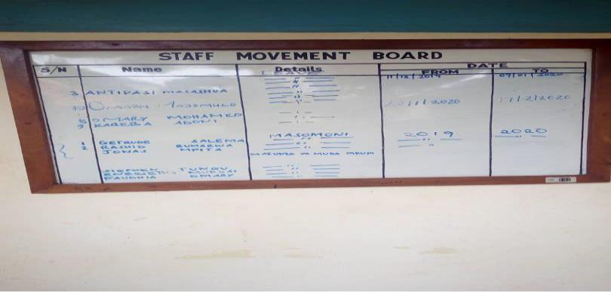
The status of the employee who has a leave is shown at the Board which is written by mark pen. Below is the picture of the board showing the number of employees who has a leave showing their names, details and start and the ending day of the leave. Thus, every employee will know who is going for a leave and who is present.
Figure 2.2: Showing the status of leave at MORUWASA

2.1.2 Drawbacks of the Existing Solution
In the current system there is loss of time for the leave or training to be approved and also this approach causes the loss and poor management of employee’s information, since data are stored in the manner that can be damaged at any time. Also, when some needs the information about a certain employee it makes him or her to stay some minutes while finding the file of the particular employee and hence lead to time consuming.

2.2 Related Works
This involves the review of some of the relevant and recent scholarly work on the importance of leave and training management system to organizations, types of methodologies for developing of software, and on programming methods. This literature review shows that for the development of “MORUWASA leave and training management system”, agile is the most appropriate development methodology, and Model View Controller is the preferable software pattern for programming the system. It also shows that JavaScript or node js is the ideal tool for developing this web-based leave and training management system.

1. Ice Human Resource Management System
Icehrm, this is Human Resource management system which was developed in USA with the following modules employee management, Leave management, attendance management, payroll system, training system, performance system, travel management system in which the leave management system performs the following functions, define leave types, one level of leave approves, manage working days, manage holidays, leave accrual support, leave request cancellation, leave note, leave rules, leave group, ability to define percentages and availability periods for leave carry forwarding.

Project Gap
MUROWASAs’ system in inefficient and incomplete Human resource management system thus a need for a human resource with fully integrated features and advance components is there. The mentioned existing software is to be purchased and there is where the disadvantage arises. Purchased software’s are accompanied with some limitations which are;
- Despite the presence of good existing human resource systems, all of them are to be purchased so the purchasing organization will suffer some consequences such as lack of control and ownership.
- Though purchased software may be cheaper initially it costs may grow overtime and some licenses tend to be time limited
- Purchased software also lack focus on requirements, thus there is no guarantee that the software will match the need of particular companies’ requirement
- Purchased software’s may be customized but the cost of integrating and changing the system could be high.

Knowing this our stakeholder MORUWASA would suffer the challenges mentioned that is why in-house build software will be advantageous to use than purchased and customized software

2. Human resource master
HR Master is real time, multiuser system, facilitating the management of human resources throughout the organization in a distributed fashion. It consists of the following modules, core employee module, recruitment, leave management, travel expense, asset, appraisal, medical claim and compensation, payroll integration with attendance, report and training. HR Master is a comprehensive web-based HR management solution which focuses on effective

In that case leave module perform the following features which involves connection of leave to payroll for paid leaves and encashment, request salary and travel allowance when applying for leaves, Public holiday accumulation as complementary leave, automatically send personalized email on specific events. comprehensive Leave Master which helps in implementing organization leave policies, centralized absence management which ensures that your resources are managed well, obtain confirmation of approved leave via email, set a maximum number of days that can be carried into the next year, according to your company policy, Employees can view current leave balances, request leave, view past leave history and managers can review and approve leave applications on the dashboard.

Project Gap
HR master System is expensive for the client because it has too many features which are not used at MORUWASA like integration of payroll system with the leave management system. Hence, due to that the leave management system should be developed in order to meet with the requirements of MORUWASA.

3. ARUTI payroll and Human Resource Management System
ARUTI payroll and Human Resource Management System consists of sub components which are Aruti performance and assessment management, a payroll and training system to measure employees earning and deductions accordingly. The system is for sale and but the management still belongs to the system vendors even if the system is already purchased.

2.3 Overview of the Proposed System
The proposed solution will help the HR manager to easily review the history of the employee leave before give him or her a leave or training and then employees will be able to view the status of their leave and the leave balance on the system, this help the development of the organization since employees can not apply the leave before check for the status by considering number of the people in the respective section who has a leave and who are present. Also, the proposed system will help to remove all paperwork concerning with leave and training activities in the organization and also the data or details related to the employees about leave or training will be stored on the real time database and hence lead for easy access of data even if thirty years has passed the data of leave or training will be available.

The proposed system is divided into three components;
- A web application for providing interaction with the users of the system
- A server software that directly interacts with the web application and database in order to provide required response to the user.
- Database and content repository, this contains information from different users of the system also the repository provides different resources to be used by the teachers.

Work through Diagram of the proposed solution
This is the diagram which the whole processes from an employee start to request leave to point when it is back to the employee again by showing the status of either approved or disapprove or rejected. The figure 2.3 shows the flow of the leave-management.

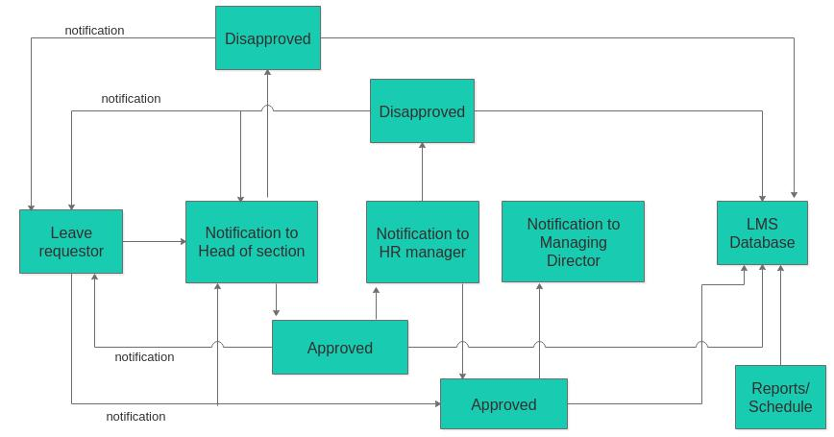
Figure 2.3: Showing the work through of the proposed solution

2.4 System Development Model

A Software Development Life Cycle (SDLC) binds to the important stages that are necessary for developers like planning, analysis, design and implementation. Several SDLC models in use include Waterfall, Agile, V-Model, Rapid prototyping, Spiral, etc. Most developers considered most commonly known and used models which are Waterfall, Agile and V-Model. A comparative study is conducted on these models before choosing the most appropriate model for the development of this leave and training management system.

Comparative Study on Development Methodology

2.4.2 Agile Model
The term agile stands for 'moving quickly' and therefore this methodology requires a team of skillful members who can challenge the fluctuating requirements. In this method, the software is released frequently with more updates and this makes customers more satisfied.

Advantages of Agile Model
Has ability to respond to the changing requirements of the project. No guesswork between the development team and the customer, as there is face to face communication and continuous inputs from the client.

2.4.3 Pattern-Oriented Software Architecture

Creating of interactive software systems with multiple types of user interfaces is expensive and with high error scope, when the user interface is closely interwoven with the functional core. This problem can be avoided by the separating user interface tasks from the functional core. To solve this problem, two software patterns are used and they are related to the way of building the applications user interface which are MVC and PAC.

2.5 System Architecture

Client-server refers to the way in which software components interact to form a system. There is a client process, which requires some resource, and a server, which provides the resource. According to Thomas Connolly et al (2005), Client server models can mainly be classified into two categories, namely 2-Tier Client/ server Architecture and 3-Tier Client/Server Architecture. 2.5.1 Three tier client/server architecture from the figure 2.2 below illustrates the three tier client/server architecture, the main components include the following
- The user interface layer, which runs on the end-user’s computer (client). This system involves the interaction with the web browser.
- The business logic and data processing layer. This middle tier runs on a server and is often Called the application server. One application server is designed to serve multiple clients.
- The system will use Apache as its web server, a DBMS, which stores the data required by the middle tier. This tier may run on a separate server called the database server
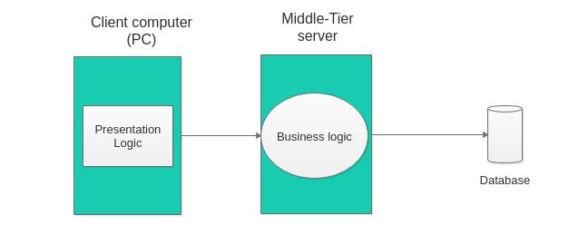

Figure 2.4: Showing the system architecture

CHAPTER THREE

METHODOLOGY

3.1 Overview

This chapter covers the detailed explanation of methodology that is being used to make this project complete and working properly. Methodology is the systematic, theoretical analysis of the methods applied to a field of study, or the theoretical analysis of the body of methods and principles associated with a branch of knowledge. It, typically, encompasses concepts such as paradigm, theoretical model, phases and quantitative or qualitative techniques (Irny & Rose, 2005).

3.2 Project Methods
This part describes in detail different methods that were used in requirement gathering and the method used in the undertaking of the whole project. The methods mainly used in requirement gathering stage was questionnaires and the method used in the project execution is agile development methodology.

3.2.1 Requirements Gathering Method
In the requirement gathering process the techniques used were the following

Interviews
Interview refers to the one on one conversation where one(interviewer) asks question and the interviewee gives answers. In this technique different interview session were contributed on the issues of leave and training management system.
Also, a phone conducted interview with the MORUWASAs Human resource manager was done with a list of structured questions where the product of the interview was recorded in a phone call record.

Observation
An observation on the current HR system at MORUWASA was done where it was notices that most HR modules are still Manual as seen. Also other observations were done at the IT department on viewing systems which were already are computerized.

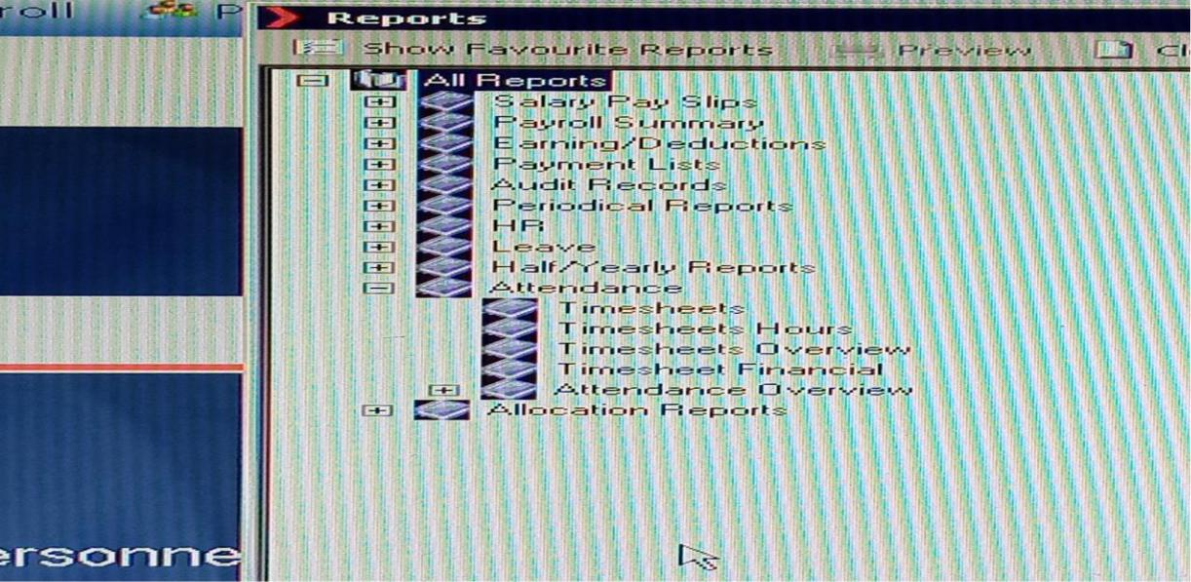
Figure 3.5: Showing some of the modules which are manual at MORUWASA

Online research.
A lot of online research was implemented in literature review phase and on looking for existing systems for payroll management and performance appraisal.

3.4 Software Development Method

Agile methodology will be used to implement the project. The reason for selection of this methodology is because it allows recurrent alteration which is good for projects with yet unclear requirement specifications. Also, it allows more customers involvement through the development process and it is good for projects that should be quickly delivered. The agile process flow is shown in Figure below.

The agile development methodology is the among of the techniques which will used or assists to deliver the good or best solution. I have decided to use this approaches because it try to minimize risk (such as bugs, cost overruns, and changing requirements) when adding new functionality.

Advantages of Agile Development.
- The cost of implementing requirements changes is reduced.
- RAD-based methodologies (Agile) are well suited for projects with short time schedules as they increase speed
- It is easier to get customer feedback on the development work that has been done. Customers can comment on demonstrations of the software and see how much has been implemented. Customers find it difficult to judge progress from software design documents.
- Early delivery and deployment of useful software to the customer is possible, even if all of the functionality has not been included. Customers are able to use and gain value from the software earlier than is possible with a waterfall process.
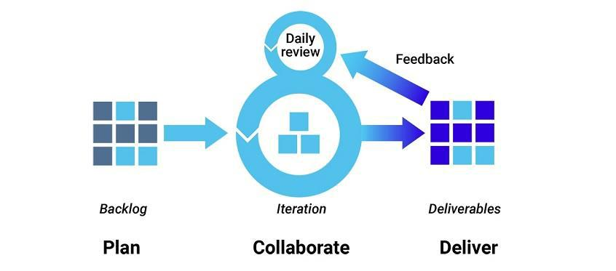

Figure 3.6: Showing the agile development processes

3.3 Data Analysis and Results

3.3.1 Data Analysis
From various sources cited before a need to automate the Human Resource Module is so highly in demand. From the interview conducted with the HR and IT department at MORUWASA, both departments had a wish to convert the all of their HR modules into automated modules. Their need was also demonstrated by their initiation in re-engineering the business process of payroll system and the attendance system. They have also employed two new programmers so as to quicken the development process.

3.3.2 Data Results

From the analysis stated above, a conclusion reached is to help the MORUWASA HR department in achieving their goals of automating its HR modules by designing and implementing an automated leave system with the training module.

Table3.1: Showing the interview questions and the response
S/N | Questions | Response
1 | How do you manage human resources at MORUWASA? | Some activities are manually managed and others are computerized.
2 | What are the challenges your facing on issues of human resources? | Lack of integrated HRMS
3 | Does the employee apply for a training? | No, they are been chosen to attend a certain training?
4 | How do they know if they have been chosen to that training? | They call him or her and be informed
5 | Did they write a report? If yes who is responsible to review that report? | Yes, the report is to be reviewed by the HR manager, managing director and also to the employee.
6 | How do you store those reports after being submitted? | It is manually, no database
7 | How do you know if there is training somewhere? | The letter is coming which inform the employee to attend the training.
8 | Which method are you using for requesting leave and in which way is the leave being approved? | It is manually, it is approved via HOS, HR manger, MD.
9 | How many leave types are you offering to the employee? | There 5 leave type
10 | Is there any effect to the attendance system on leave? If yes how? | No effect
11 | What are the challenges your facing on using your current leave system? And what are your suggestions on solving those challenges? | Time consuming, and the computerized leave management system is required.
12 | What is the process for leave requesting and approval? | Employee should fill the form and that form should be approved by HOD, HR manager and last to MD

CHAPTER FOUR

SYSTEM ANALYSIS AND DESIGN

4.1 Requirements Analysis

Requirement is simply a statement of what the system must do or what characteristics it needs to have. It involves the description of what software should do (functional requirements) and what characteristics the system should have (non-functional requirements).
This section explains about identified system requirements based in to two categories, functional and non-functional requirements.

4.1.1 Functional Requirements

These requirements are observable tasks or processes that must be performed by the system under development so as to achieve its main goal. This includes all tasks that will be automated by the system. The following are the functional requirement of the system under development

Functional requirement for leave management system:
- System should allow user to register the employee in the organization
- System should allow user to view their profile and update them if else
- System should allow user to apply for the leave and waiting for an approval after being reviewed by Head of section, HR manger and also the Managing Director.
- System should allow user to view and reply for the notification of the leave request or approval.
- System should allow user to view the leave status and leave balance.
- System should allow administrator to update any information or data related to leave.
- System should allow user to view the leave history of the employee before approve for the leave.
- System should allow user to set the rules or policies on the leave.
- System should allow user to create the leave report according to time.
- System should allow user to upload any document related with leave request.

Functional Requirement for Training Management System;
- System should allow user to view the present or available training and user can apply for that training
- System should allow administrator to update the training available.
- System should allow user to upload the report after back from the training.
- System should allow administrator to upload different materials related work

4.1.2 Non-functional Requirements

These requirements are qualities or standards that the system under development must have or comply with, but which are not tasks that will be automated by the system. The following is the list of non-functional requirements for leave and training system that the development has:
- The system must display an error message once the password inserted is incorrect
- The system must display an error message once the password inserted is incorrect
- The system must respond to a request as fast as possible
- The user must enter the password correctly within 3 attempts
- The system must be secure
- The system must have a backup system to enable recovery of data in case any system failure occurs
- The user can log in and log out of the system at any instance

4.2 Use Case Analysis

Use cases refer to the diagrams that used to explain and document the interaction that is required between the user and the system to accomplish the user’s task. The following are the use casehardening to the user roles

Use Case Analysis for Leave

4.2.1 Employee and Managing Director

This role refers to the category of user (i.e. Employee) who has already registered in the system and logged in to the system in order that he or she can be able to view the leave status, leave balance and also can apply for a leave and also can view the notification related with leave. Also, the role refers to
category of user (i.e. Managing Director) who has already register on the system and can login to the system and able to manage the approve of the leave and to manage the notification of the request and he or she is the last approve on leave request.
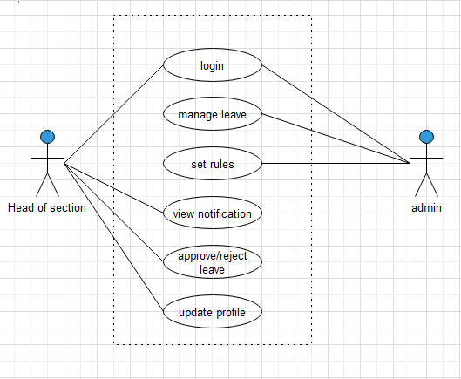

Figure 4.7: Showing the use case of employee and managing director

4.2.2 Admin and Head of Section

This role refers to the category of user (i.e. admin) who has already registered in the system and the logged in to the system in order that he or she can set rules and also can manage the leave process in the system. Also, the role refers to the category of user (I.e. Head of section) who has already register on the system and can login to the system and able approve for the leave requesting from his or section.
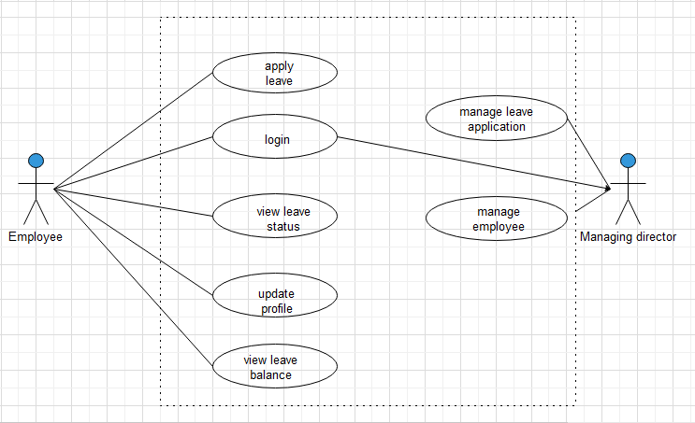

Figure 4.8: Showing the use case of admin and Head of section

4.2.3 HR Manager

Also, this is the actor with the category of user (i.e. HR Manager) who is also responsible to view the leave history and then can approve on it or reject on that leave and create report.
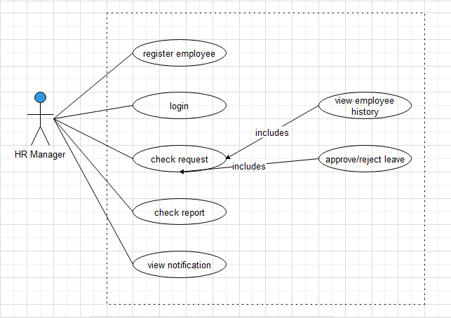

Figure 4.9: Showing the use case of HR manager Use case analysis for training

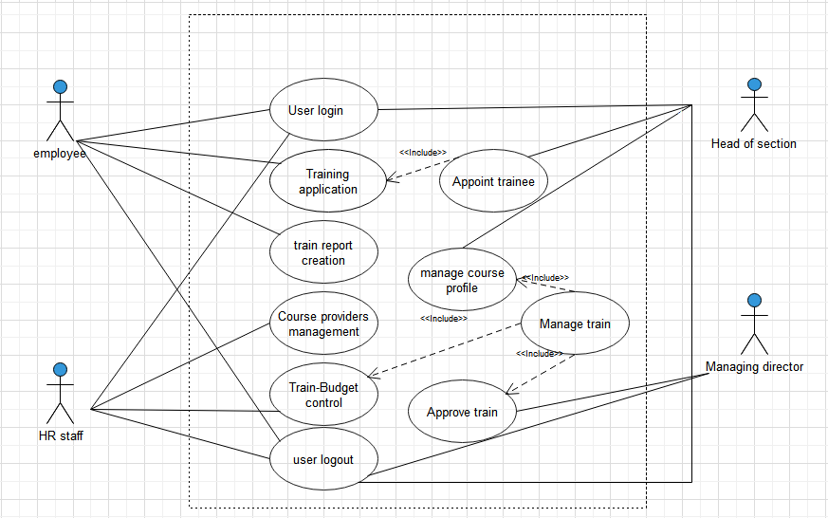
Figure 4.10: Showing the use case of training system

4.3 Use Case Description for Leave and Training Management System

This section gives more description about the above described use case

Table4.2: Showing use case for login

Table 4.3: Showing the login
Use case name |  | Login or Logout
Description |  | Users of the system can use the system features only after the login.
 |  | Login is used for identify the user is authenticated or not.
Basic flow |  | 1. | Open the login page.
 |  | 2. | Enter login credential (User-Id and password).
 |  | 3. | Click on the Login button.
 |  | 4. | Validate the user.
 |  | 5. | User Homepage is shown.
Priority |  | High
Actors |  | Employee, HR manager, Head of section, Managing Director and
 |  | Admin

 |  | Table 4.4: Showing Employee Registration use case
Use case name |  | Employee registration
Description |  | Employee registration is done by HR Manager. It requires all the
 |  | Details related to that employee. It is necessary for all the employee.
Basic flow |  | 1. Login to the system as HR Manager.
 |  | 2. | Open the Employee Registration page.
 |  | 3. | Fill all the details of employee.
 |  | 4. | Click on the Register button.
 |  | 5. | Validate all the fields and ask for Confirmation.
 |  | 6. | Confirmation Message shown for Successfully Register
Priority |  | High
Actors |  | HR manager

Table 4. 5 Showing apply leave use case

Use case name | Apply leave
Description | Leave application is submitted by user for taking leave. User can select the type of the leave and also submit a document related to leave reason or any other document.
Basic flow | - Login to the system  - Click on apply leave  - Select the leave type  - Fill on required details  - Click non apply button  - Validate the form and ask for confirmation  - The validation message is send to user.
Priority | High

Table 4.5: Showing apply leave use case
Use case name | Apply leave
Description | Leave application is submitted by user for taking leave. User can select the type of the leave and also submit a document related to leave reason or any other document.
Basic flow | - Login to the system  - Click on apply leave  - Select the leave type  - Fill on required details  - Click non apply button  - Validate the form and ask for confirmation  - The validation message is send to user.
Priority | High

Table 4.6: Showing approve/reject leave use case
Use case name | Approve/Reject Leave
Description | Leave application submitted by employee can be viewed by Head of Section at first time then to HR Manager and then the last approve is done by Managing Director after checking all the details of application of HR manager and Head of section then approve or reject the leave application.
Basic flow | 1. Login into system.  2. HOD fill the approve detail.  3.HR manager click on view leave history button and then approve/reject  4.MD also can approve or reject
Priority | High

 |  | Table 4.7: Showing View notification use case
Use case name |  | View notification
Description |  | Notification about leave application will sent to related authority. And
 |  | Notification about status of the application is also sent to employee.
Basic flow |  | 1. Login into system.
 |  | 2. Click on Notification button.
 |  | 3. List of notification is shown.
Priority |  | High
Actors |  | Employee, Head of section, HR manager and MD

Table8: showing use case description for admin
Use case name |  | Set rules/policies
Description |  | Administrator will set the leave rules. Administrator can also add new
 |  | Rules and can modify existing rules.
Basic flow |  | 1. Open the administrator login page.
 |  | 2. Login as administrator.
 |  | 3. Add, Modify rules for employee.
Priority |  | Medium
Actors |  | Admin

 |  |  | Table 4.8: Showing View leave history
Use case name |  |  | View leave history of employee
Description |  |  | Leave history contains the details of all the leave application history
 |  |  | and available leaves for that user.
Basic flow |  |  | - Login into system.  - Click on Notification button.
Actor |  | Employee

Use Case Description for Training Management System

Table 4.9: Showing upload report use case
Use case name |  | Upload report
Description |  | The training system should allow the employee to upload the report
 |  | after back from training.
Basic flow |  | 1. Login into system.
 |  | 2. Click on choose file
 |  | 3. then upload the document.
Priority |  | High
Actors |  | Employee

Table 4.10: Apply training use case
Use case name |  | Apply training
Description |  | Training application is submitted by user for requesting training. User
 |  | can select the type of the training and also submit the reasons of
 |  | Requiring the training.
Basic flow |  | 1. Login into system.
 |  | 2. Select the available training.
 |  | 3. Then submit.
Priority |  | Medium
Actors |  | Employee
 |  | Table4.11:showing add training in the system
Use case name |  | Add training
Description |  | The training will be added on the system so as employees can apply
 |  | on it or the HR manager can select employee to attend the training.
Basic flow |  | 1. Login into system.
 |  | 2. Click on add training
 |  | 3. Then submit.
Priority |  | High
Actors |  | Admin

Table 4.12: Showing training approve use case
Use case name |  | Approve
Description |  | After the applying for the training then it can either be approved or
 |  | rejected due to different conditions
Basic flow |  | 1. Login into system.
 |  | 2. Click on approve or reject
 |  | 3. submit, then employee get notification.
Priority |  | High
Actors |  | HR manager, MD

4.4 SYSTEM DESIGN

4.4.1 Overview
This chapter explains the design process of the project, Design as the part of the project defines the architecture, modules, interfaces and data flow for the system in order to satisfy the specified system’s requirements. This chapter explains about system process modeling, Data Flow Diagrams, work through diagram for leave system and the architecture of the system.

4.4.2 Process Modeling
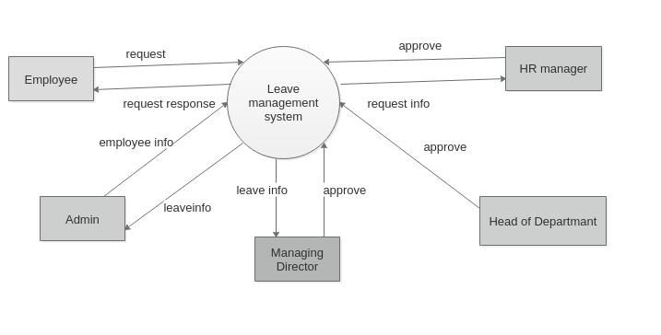
Process model used to describe business processes, the activities that users do. In this section I have used data flow diagram which is most commonly used process modeling techniques. Data flow diagram (DFD) shows a way in which information flows inside the system. The following figures below shows the DFD of the leave and training management system which are drawn according to the number of entities.

Figure 4.11: Diagram for leave management system DFD for HR Manager

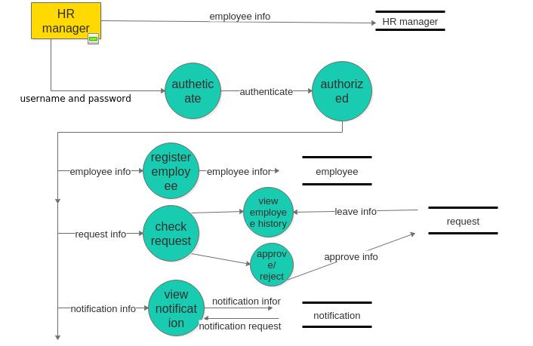

Figure 4.12: DFD for HR Manager

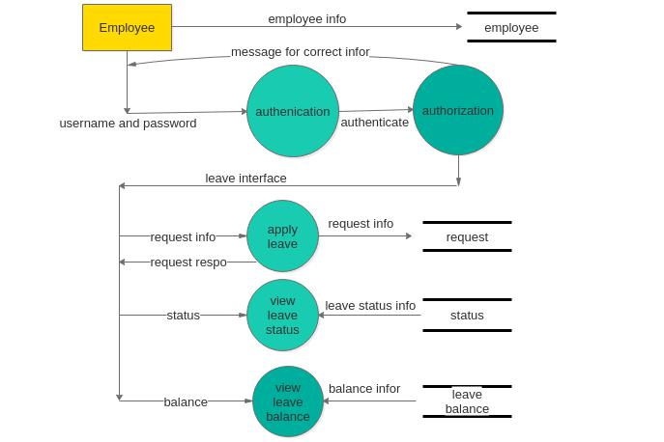

Figure 4.13: DFD for Employee

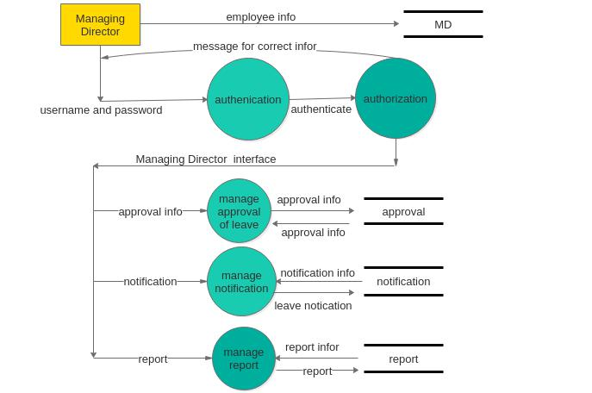

Figure 4.14: DFD for Managing director

Context Diagram for Training Management System

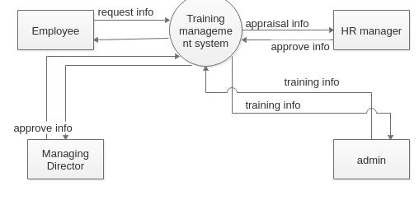

:
Figure 4.15: Showing the DFD level one of Managing Director

Leave and training system is a client-server, web-based system with three tier architecture. The system consists of three major components

4.3.3 Leave and Training system architecture

The Mongo Database server for storing all the information and data needed, including the means to link to the teaching content repository, Express web application server that controls the communication (basic system functionality) and the client that is used by users to access data from the server (web interface accessible via standard web browser). The three components are networked to facilitate communication among them.
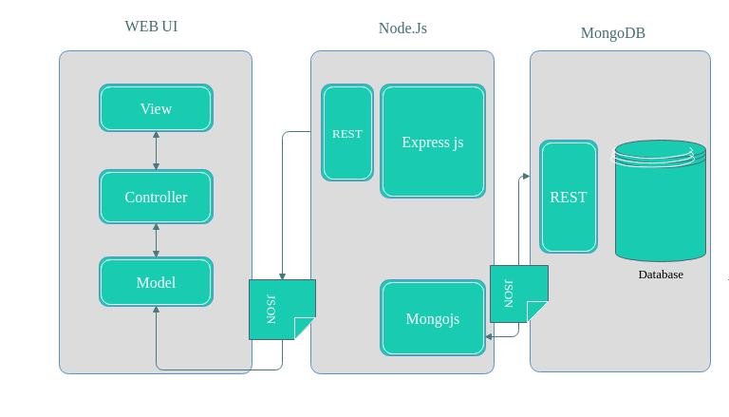

Figure 4.16: Showing the architecture of the leave and training management system

As illustrated in the figure 4.16 the architecture consists of the following

i. The client Tier: also known as the user interface layer runs on the end-user’s computer. This layer is the Web User Interface (UI). It is also referred to a front end. It consists of model view and controller. Where by the model defines what the app should contain, the view defines how the app’s data should be displayed and the controller contains the logic that updates the model and/or view in response to input from the user of the app.

- The application tier: also known as business logic and data processing layer is responsible for interacting with the client on one side and the database on the other side. Thus, the application layer receives and process information from the client, retrieves information (data) from the database. Express web server is used to manage all activities in this tier, this server is asynchronous and non-blocking thus making the server performance effective. This server operation uses REST API, which is the application programming interface that uses HTTP requests to GET, PUT, POST and DELETE data. Also, data between these tiers are exchanged through JSON (JavaScript Object Notation) which is easier to manipulate compared to other means such as XML.

iii. The database Tier: This is the place where data is stored. The database server maintains the data needed for the web application, it stores data including links to the teaching content32 repository and controls basic functionality. This part resides on a separate server known as a database server. The MONGODB is used in this tier; MONGODB is a cross platform document-oriented database program. It is classified as NoSQL database. It uses JSON like schemas. The advantage of using MONGO DB is that it is very scalable and also provides fast response time.
Figure 4.17: ER Diagram
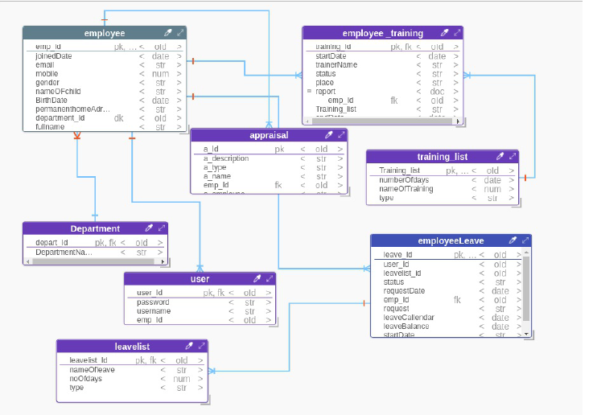

CHAPTER FIVE

SYSTEM IMPLEMENTATION

5.1 Overview
The implementation is entirely divided into two parts, the front end development and a backend development, the front end development is main implemented using HTML, CSS and JavaScript and the backend is implemented using Node Js and Express which are frameworks based on Java Script.
The database is implemented using MongoDB which is a cross-platform document-oriented database. Classified as a NoSQL database, MongoDB uses JSON-like documents with schemata.

The leave management system is developed in four levels which are first the employee is requesting a leave by filling the application details then the request is approved by head of section then it passes to Human Resource manager for approve and finally it approved by Managing Director of an organization. But also training management system is developed in three levels which are first employee can upload or apply for training then it directed to Human Resource manager then can approve or reject the request finally to Managing Director where he or she can add training according to their need.

5.2 Implementation Strategy
For the system to work first the user must have the access to login to the system, admin is given the access to login to the system in which he or she has a privilege to add or to register other users to the system so as they can be able to access their services according to their levels. To do so a user registration and authentication must be developed that should work across the whole system. Also the user should be able to request leave or training and waiting for the response on that request after he or she is logged in the system also a user can send response after he or she is logged in the system. And finally the logged in user should be able to upload the training report and add training to the system.

5.3 Coding of the Component
The system is divided into 4 main modules, the registration and authentication module, requesting module, uploading module and database module all these modules work together to achieve the project specific objectives.

5.4 Component Prototype
The objective of the system is to make sure that employee can be able to apply for a specific leave or training and he or she can be able to get the approved or rejected request of his or her applications also the employee is able to upload the training report and the Human Resource manager is required to add the available training to system so as employees can apply on that training, also employee must be able to see the available training in the system. But also employee is able to view his or her leave history in the system.
The figures 5.18 to 5.21 show the interface of employee from login page to where he or she can see the approved or rejected leave history. But the login page is common for all users but will have different access, thus from figure 5.22 to 5.25it show the Managing Director interface where he or she can approve or reject leave and register the users in the system and 5.26 show the interface of the employee on training system. And figure 5.27 to 5.28 showing the some of the database design.
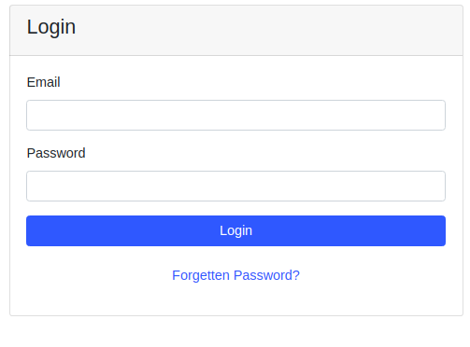

Figure 5.18: Login form

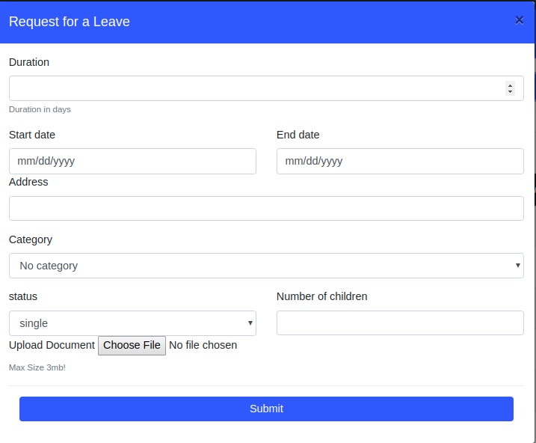
Figure 5.19: Requesting or application form

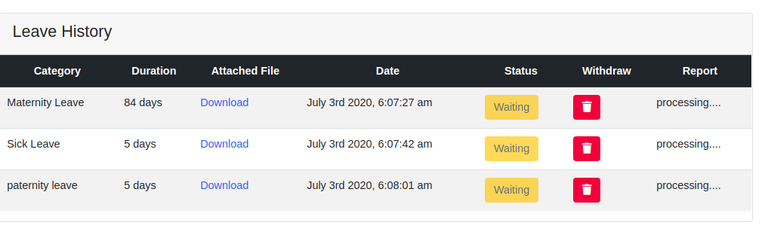
Figure 5.20: Leave history of employee before approved

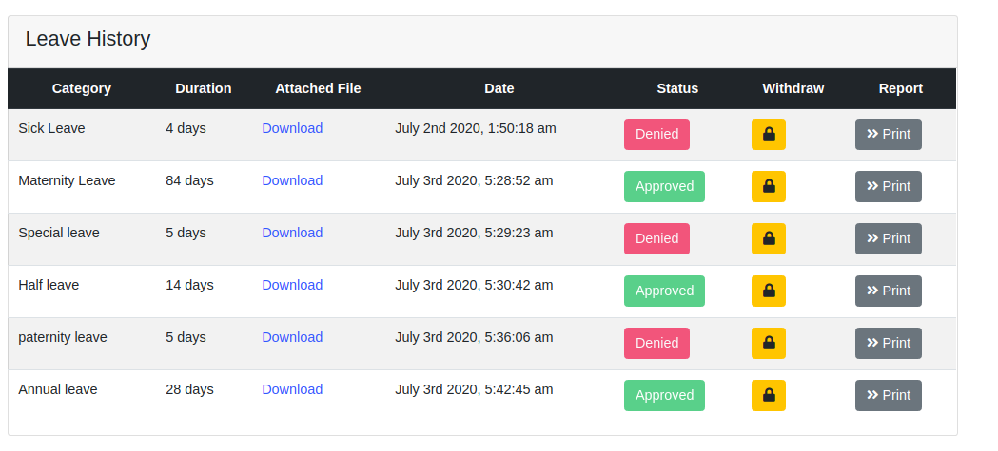

Figure 5.21: Leave history of the employee after approved
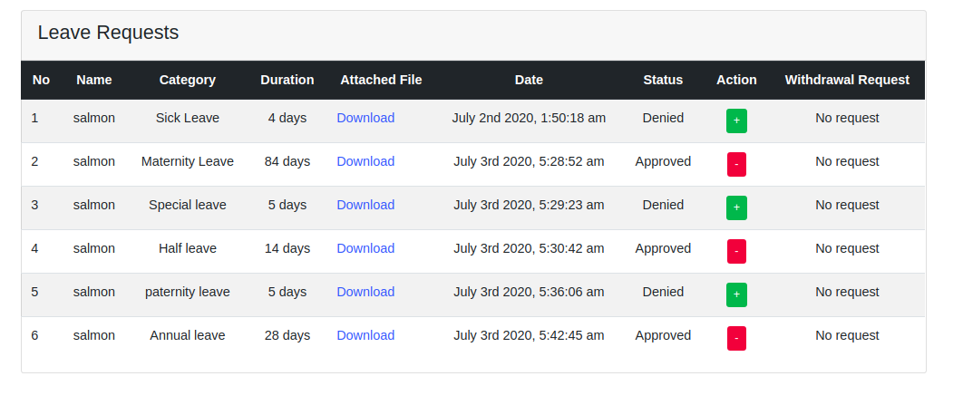

Figure 5.22: Managing director leave requesting by employee
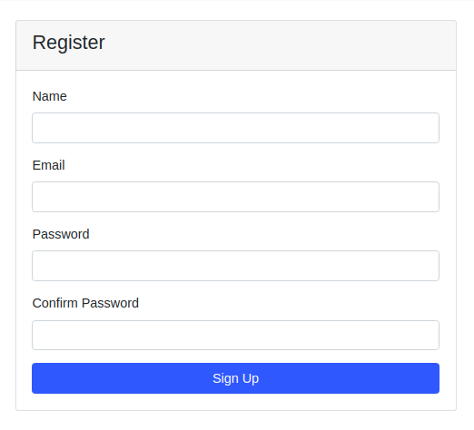
Figure 5.23: Register user

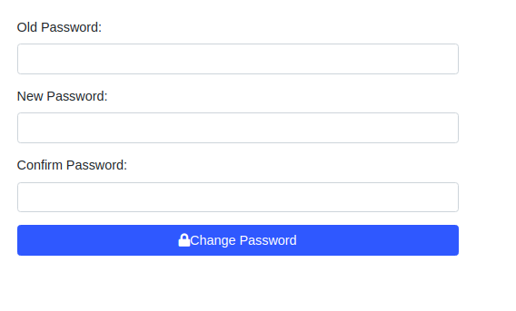

Figure 5.24: Change password

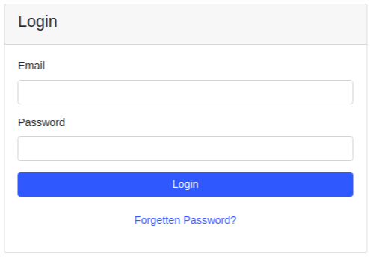

Figure 5.25: Login Interface

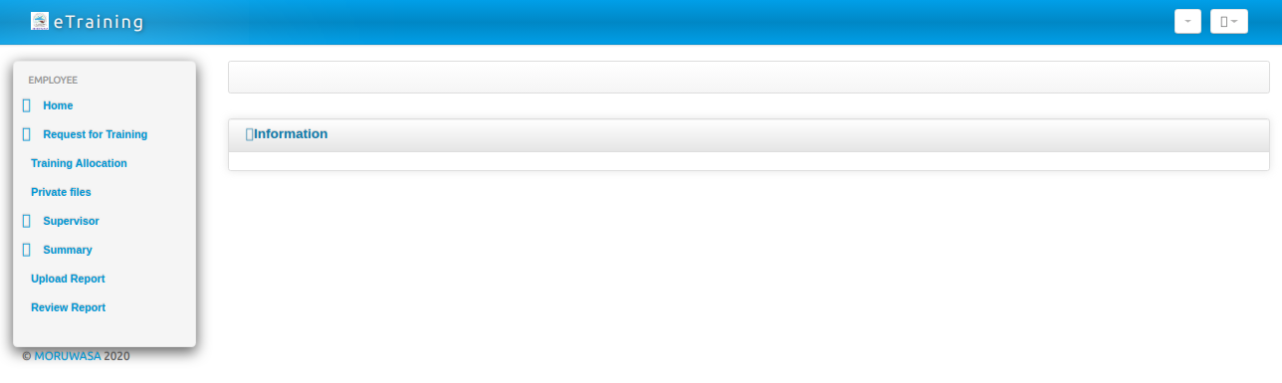
Figure 5.26: Employee interface of training system

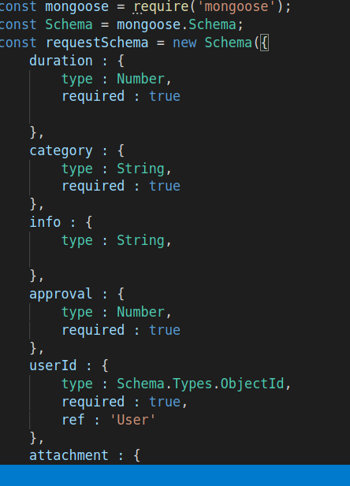
Figure 5.27: Requesting schema

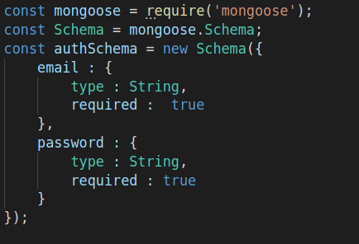

Figure 5.28: Managing director login Schema

CHAPTER SIX

CONCLUSION AND RECOMMENDATION

6.1 Conclusion
This report gives a detailed information on designing and implementation of Leave and training management system, this project will create a bridge between employees and access to a leave and training, hence it will enable them to enhance their leave and training activities to be conducted in the good manner. Through training the employee will get more knowledge which will help them to deliver a required and quality products or services at MORUWASA.

6.2 Challenges
During the designing of this project I encountered different challenges which includes;
- Limited time, the semester schedule was limited and as a result time to perform more research was minimal
- Class activities, it happens when was proceeding with the design I was being assign with class assignment which it causes late of completion of the design, but in actual sense I tried to my level best to accomplish it on time.
- Lack of money to move to Morogoro for requirement gathering

6.3 Recommendation
This project takes advantage of fast growing Information Technology (IT), which comes with many advantages includes flexibility and accessibility, hence I recommend the government institutions to use the computerized systems like leave and training management system in their organization which helps in storing data in the good way thus can be accessed at any time when needed and also it save much time and lead to development of the organization.

6.4 Work which have been Done
Requirement gathering and analysis, design of leave and training modules, database design and some parts of implementation.

6.5 Work to be done
Some parts of implementation of the leave and training system, testing of the system and documentation.

REFERENCES

- Craig Laman (October 20,2004). Applying UML and Patterns. USA: Addison Wesley Professional. P 239-638.

- Dennis, Wixom, Roth (2012). System Analysis & Design. 5th ed. USA: Library of Congress. 101-232, 259-405.

- Bhattacharyya, B. (2017, august 1). Functions of human resource management. Functions of human resource management.

- https://kissflow.com/hr-process/leave-management/

APPENDECIES
Appendix A1 is time scheduling
Table 13: A1 Time scheduling
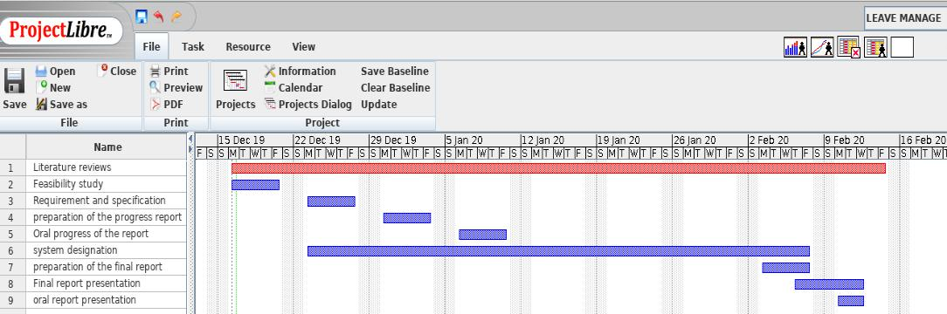

Appendix A2 is a time scheduling for second mid semester

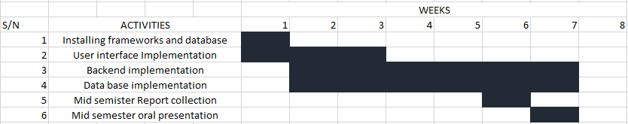
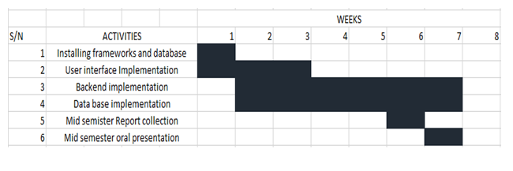

MAMLAKA YA MAJISAFI NA USAFI WA MAZINGIRA MOROGORO

MAOMBI YA LIKIZO
(Kwa ajili ya Watumishi wa Kudumu na wa Mkataba Maalum)

Ijazwe kwa HERUFI KUBWA katika nakala mbili. Nakala moja atarudishiwa mwombaji kama ni mamlaka ya kumruhusu aende likizo baada ya hatua zote kukamilika.

Sehemu A – Maelezo ya Mwombaji (Ijazwe na mwombaji)

- Jina kamili:………………………………………………………………………………………………………………………………………………………
- Sehemu:…………………………………………………….Idara:………………………………………………………….…………………………..….
- Kazi:……………………………………………………… 4. kituo cha kazi………………..………………………………….………………………...
5. Ninaomba likizo ya siku……….kuanzia tarehe:……………………20……...mpaka tarehe……………………..…….20………………
- Nataka kwenda ………………………..ambapo nitakaa kwa muda wa siku………………………………………………………………..…
Anwani yangu nitakapokuwa likizo ni……………………………………………………………………………………………………………..
- Mume/Mke wangu na watoto ……………..ambao habari zao zimeelezwa hapa chini
watafuatana nami.
Jina la Mtoto | Tarehe ya kuzaliwa | Jina la Mtoto | Tarehe ya kuzaliwa

- Mshahara wangu ni Sh……………………………kwa mwaka na ninataka mshahara wa likizo ulipwe/usilipwe.
- Katika Benki ya ……………………………………………………….…….iliyoko …………………………………………….…………………
- Kabla ya kuondoka kwenda likizo.

Tarehe:………………………20……….... Saini ya Mwombaji………………………………….…………………..

Sehemu B – Maelezo ya Likizo (Ijazwe na Mkuu wa Sehemu anayofanyia kazi)
9. Nimekubaliana na maelezo yaliyotajwa hapo na ninaruhusu/siwezi kuruhusu likizo itolewe kwa sababu
………………………………………………………………………………………………………………………………………………………………………

Tarehe:……………………………20…... Saini:………………..………………………………..………..

Kumbukumbu:…………………………… Kazi:…………………………………………………………….…
Sehemu C – (Ijazwe na Afisa Utumishi)
10. Nimehakikisha kwamba:-
- Tarehe aliyoondoka kwenda likizo mara ya mwisho/tarehe aliyoajiriwa mara ya kwanza ilikuwa…………………...…
- Kwa hiyo anastahili kuwa na siku …………………………za likizo alizopata tangu aanze kazi au aende likizo mara ya
mwisho na siku nyingine…………………………………..………………………………….zilizokuwa zimewekwa hapo mbeleni.
(c) Alipewa nauli kwa ajili ya likizo aliyochukua kutoka tarehe …………………………mpaka…………………………………….…

11. Silikubali/Nakubali ombi hili la likizo kwa sababu zifuatazo:-
……………………………………………………………………………………………………………………………………………………………………..

Tarehe:……………………………………..20.……. Saini:………………………………………………
Kumbukumbu:…………………………………….. Kazi:……………………………………….………

Sehemu D – Ijazwe na Mkuu wa Idara/Mkurugenzi Mtendaji)
12. *Ninakubali/Sikubaliani na maombi ya likizo hii kwa sababu zifuatazo:-
………………………………………………………………………………………………………………………………………………………………………

Tarehe:……………………………………….…..20.……. Saini:…………………………………
Kumbukumbu:……………………………………..……. Kazi:…………………………………
*Futa yoyote isiyofaa.

